**The Hong Kong Polytechnic University**

**Laboratory Report**

**FUNDAMENTALS OF MATERIALS SCIENCE AND ENGINEERING**

**ENG2001_20221_C**

**(LIU Qiang)**

**Measurement of the Mechanical Properties of Materials**

**(Rockwell Hardness & Uniaxial Tension Test)**

Name: QIN Qijun

Student ID: 21101279D

**Abstract**

This experiment aims to deepen the understanding of the properties of materials in the tensile state. The experiment was conducted by using tensile testing machine and Rockwell hardness tester for tensile and hardness testing of Mild Steel and Acrylic and processing the obtained data to derive general tensile and hardness properties of different materials.

**Introduction**

The objective of this experiment is to test the material properties of Acrylic and Steel materials. The specific material properties include Hardness, Yield stress, Ultimate tensile strength, Fracture strength, Elastic modulus, Percent Elongation, Percent Reduction in Area.

The experiment also investigated the changes in these properties compared before and after the tensile test, as well as the patterns at the fracture openings of the different materials.

The experiments were conducted using a tensile machine to obtain real-time data on the material during the tensile process, and measured the length, fracture opening thickness, and hardness of the material before and after the fracture, and then used Python programming to process and analyze the obtained data to produce the final analysis results.

After tensile test, recorded the pattern at the fracture and measured the hardness, length and thickness of the sample again

**Methods and Materials**

**Apparatus/Specimen:**

1. Rockwell hardness tester, ‘GoPoint’ GP-TS2000M(50kN) and GPTS2000S25(30kN) testing machine.

2. ‘CISRI’ 25mm Extensometer.

3. Mild Steel and Acrylic specimens in dog-bone shape.

**Experimental Procedure**

Measuring the specimens:

|  |  |  |  |  |  |
| --- | --- | --- | --- | --- | --- |
|  | *Thickness* | *Width* | *Length 1* | *Length 2* | *Hardness* |
| Steel | 2.98 mm | 10.09 mm | 49.97 mm | 99.08 mm | 82.72 HRB |
| Acrylic | 3.12 mm | 9.99 mm | 50.6 mm | 107.7 mm | N/A |

(Note: All the data are average. Length 1 is the gauge length measured by ‘CISRI’ 25mm Extensometer. Length 2 is the distance between shoulders.)

*For raw measurement please see appendix.

Performing tests:

For Hardness Test, placed the steel specimen on a Rockwell hardness tester, tested the grip section and took the average value. After tensile test, test the hardness of the edge of the fracture point of the specimen.

Installed the specimen on the 'GoPoint' testing machine and installed the 'CISRI' 25mm Extensometer on the measuring point on the specimen gauge. After initializing the device and entering the thickness, width and hardness, started the tensile test and recorded the data. The same process for Mile steel and Acrylic respectively.

After the tensile test, record the pattern at the fracture and measure the hardness, length and thickness of the sample again

Data Process:

* Calculation method for Percent Elongation and Percent Reduction in Area:

$$\%EL=\frac{Length2^{'}-Length2}{Length2}*100\%$$

$$\%AR=\frac{\left(Area*Width\right)-(Area^{'}*Width')}{(Area*Width)}*100\%$$

*Length2*, *Area* and *Width* is original value, $Length2^{'}$, $Area^{'}$ and $Width'$ is the value after tensile test.

* This experiment used python programming to process the real-time data for tensile testing. The program is divided into 9 parts:

1. Intercept all the data in the data file.

2. Linear fit elastic elongation data section.

3. Get elastic limit points.

4. Determine the yield point. (For Acrylic, use 0.2% Proof yield strength; for mile steel, determine the lower yield point)

5. Get tensile point.

6. Get fracture point.

7. Use curve to fit the plastic deformation part.

8. Integrate data to obtain elastic/hardness modulus.

* Use formula:

9. Output data and graphics.

For the detailed implementation of the program, please see the appendix.

**Result**

* **Measurement of specimens:**
  + Before

|  |  |  |  |  |  |
| --- | --- | --- | --- | --- | --- |
|  | *Thickness* | *Width* | *Length 1* | *Length 2* | *Hardness* |
| Steel | 2.98 mm | 10.09 mm | 49.97 mm | 99.08 mm | 82.72 HRB |
| Acrylic | 3.12 mm | 9.99 mm | 50.6 mm | 107.7 mm | N/A |

* + After

|  |  |  |  |  |  |
| --- | --- | --- | --- | --- | --- |
|  | $$Thickness'$$ | $$Width'$$ | $$Length1^{'}$$ | $$Length2^{'}$$ | $$Hardness'$$ |
| Steel | 1.575mm | 6.905 mm | N/A | 121.64 mm | 92.51 HRB |
| Acrylic | 3.08 mm | 9.955mm | 51.13 mm | 108.27 mm | N/A |

(Note: All the data are average. Length 1 is the gauge length measured by ‘CISRI’ 25mm Extensometer. Length 2 is the distance between shoulders.)

*For raw measurement please see appendix.

* + The Change of Measurement

|  |  |  |
| --- | --- | --- |
|  | Percent Elongation (%EL) | Percent Reduction in Area (%AR) |
| Steel | 22.76948% | 63.83097% |
| Acrylic | 0.52925% | 1.62791% |

* **Real-time Data for Tensile Testing of Steel:**
  + Tensile Test Data Graph:

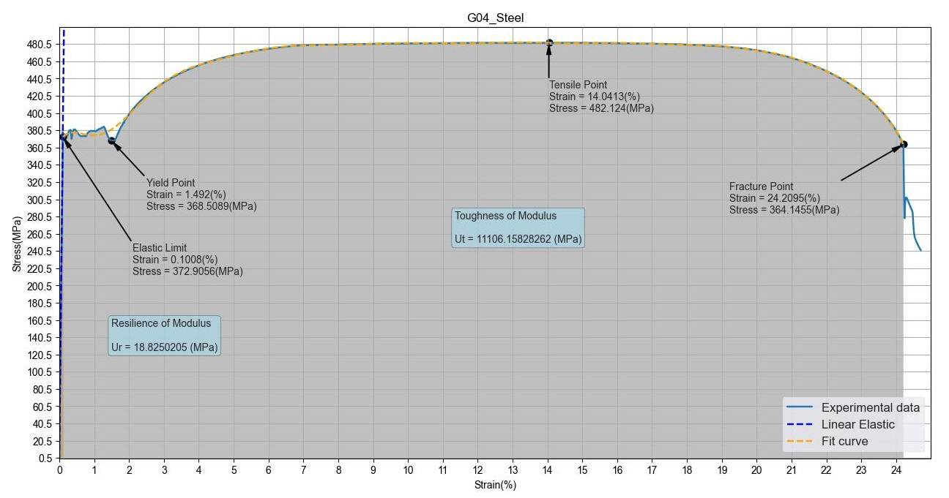

Figure : Steel test stress – strain graph

* Tensile Test Data Results:

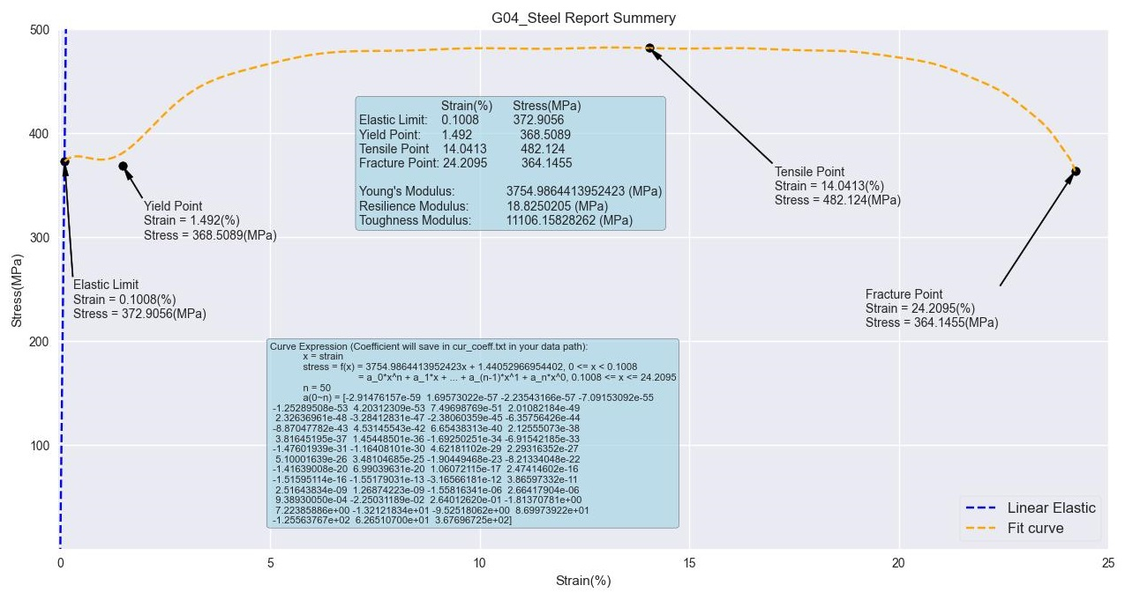

Figure : Steel test report

|  |  |  |
| --- | --- | --- |
|  | Strain (%) | Stress (MPa) |
| Elastic Limit | 0.1008 | 372.9058 |
| (Low) Yield Point | 1.4920 | 368.5089 |
| Tensile Point | 14.0413 | 482.1240 |
| Fracture Point | 24.2095 | 364.1455 |

|  |  |
| --- | --- |
| Young’s Modulus | 3754.9864413952423 (MPa) |
| Resilience Modulus | 18.8250205 (MPa) |
| Toughness Modulus | 11106.15828262 (MPa) |

* Curve Fitting:
  + - Fitting mode:

Elastic deformation: Linear fitting

Plastic deformation: Taylor series (50th degree)

* + - Parameters:

$$k=3754.9864413952423$$

$$b= 1.44052966954402$$

A = **[**-2.91476157e-59 1.69573022e-57 -2.23543166e-57 -7.09153092e-55 -1.25289508e-53 4.20312309e-53 7.49698769e-51 2.01082184e-49 2.32636961e-48 -3.28412831e-47   
-2.38060359e-45 -6.35756426e-44 -8.87047782e-43 4.53145543e-42 6.65438313e-40 2.12555073e-38 3.81645195e-37 1.45448501e-36 -1.69250251e-34 -6.91542185e-33   
-1.47601939e-31 -1.16408101e-30 4.62181102e-29 2.29316352e-27 5.10001639e-26 3.48104685e-25 -1.90449468e-23 -8.21334048e-22 -1.41639008e-20 6.99039631e-20 1.06072115e-17 2.47414602e-16 -1.51595114e-16 -1.55179031e-13 -3.16566181e-12 3.86597332e-11 2.51643834e-09 1.26874223e-09 -1.55816341e-06 2.66417904e-06 9.38930050e-04 -2.25031189e-02 2.64012620e-01 -1.81370781 7.22385886   
-1.32121834e+01 -9.52518062 8.69973922e+01 -1.25563767e+02 6.26510700e+01 3.67696725e+02**]**

$$X={\left[x^{50} x^{49} x^{48} ⋯ x^{2} x^{1} x^{0}\right]}^{T}$$

* **Real-time Data for Tensile Testing of Acrylic:**
  + Tensile Test Stress–strain Graph:

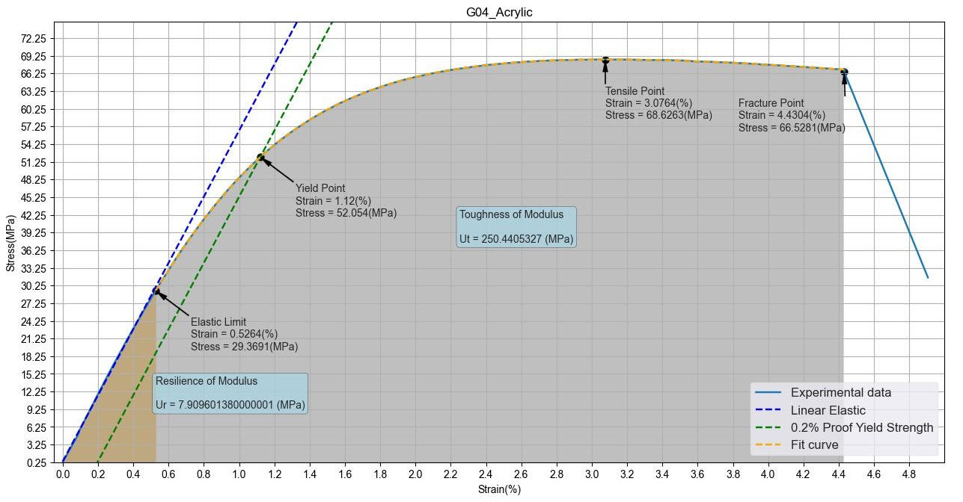

Figure : Acrylic test stress – strain graph

* Tensile Test Data Results:

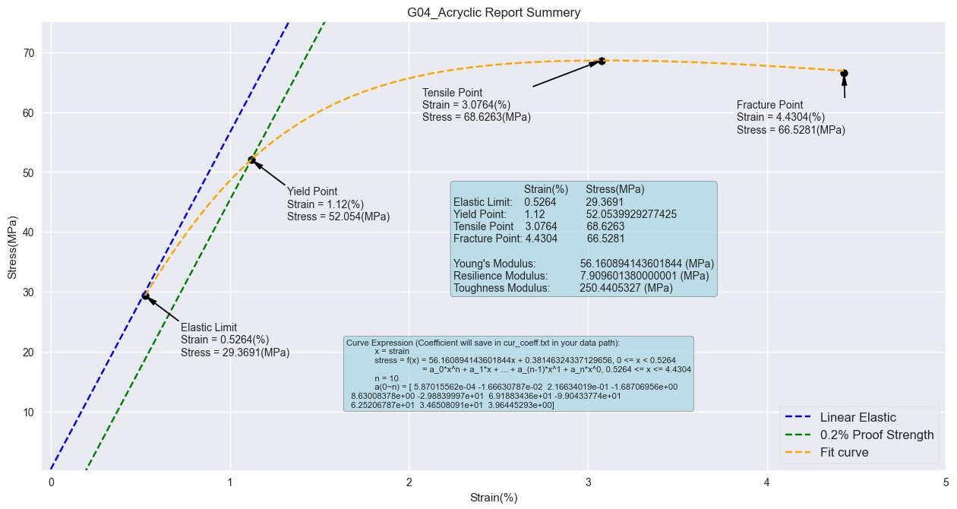

Figure : Acrylic test report

|  |  |  |
| --- | --- | --- |
|  | Strain (%) | Stress (MPa) |
| Elastic Limit | 0.5264 | 29.3691 |
| Yield Point | 1.1200 | 52.0540 |
| Tensile Point | 3.0764 | 68.6263 |
| Fracture Point | 4.4304 | 66.5281 |

|  |  |
| --- | --- |
| Young’s Modulus | 56.160894143601844 (MPa) |
| Resilience Modulus | 7.90960138 (MPa) |
| Toughness Modulus | 250.4405327 (MPa) |

* Curve Fitting:
  + - Fitting mode:

Elastic deformation: Linear fitting

Plastic deformation: Taylor series (20th degree)

* + - Parameters:

$$k=3754.9864413952423$$

$$b= 1.44052966954402$$

A = **[**5.87015562e-04 -1.66630787e-02 2.16634019e-01 -1.68706956 8.63008378e   
-2.98839997e+01 6.91883436e+01 -9.90433774e+01 6.25206787e+01 3.46508091e+01 3.96445293**]**

$$X={\left[x^{20} x^{19} x^{18} ⋯ x^{2} x^{1} x^{0}\right]}^{T}$$

* Material Pattern After Fracture:

Figure : Pattern of the specimen after fracture

**Discussion**

1. Elongation (EL) and Area Reduction (AR) of the Material:

According to the comparison, the length of both steel and acrylic samples increased, elongating by 22.76948% and 0.52925%, respectively. At the same time, their area decreased, by 63.83097% and 1.62791%, respectively.

This shows that both specimens underwent plastic deformation during the tensile phase, with elongation and necking of the specimens. This indicates that typical shear sliding occurs within the atomic structure of both, and dislocation occurs. The atoms on both sides move toward the elongated part, causing necking and elongation.

Since the steel specimen has %EL = 22.76948% > 5% which means that it is a ductile material, while the acrylic specimen has %EL = 0.52925% < 5% which means that it is a brittle material. Therefore, steel specimens will have more significant elongation and necking. According to the comparison with the actual picture, the pattern at the fracture of the metal specimen approximates   
45° shear, which is typical of the fracture of moderate ductile materials. Whereas the elongation and necking of acrylic will not be so obvious. From the picture can also be seen, the acrylic specimen fracture is not much deformation, and the fracture surface is relatively flat, belonging to the typical brittle fracture.

1. Increased Hardness of Steel:

According to the comparison before and after the experiment, the hardness of the steel increased, from 82.72 HRB to 92.51 HRB. This is probably because the atoms on the side of the specimen were subjected to tensile forces (stresses) during the tensile process causing the atoms to displace and move closer to the middle and elongation direction, resulting in an increase in internal density and stress. This is similar to Drawing cold working of the specimen, when dislocations running in different planes intersect, they cannot move towards each other and cause dislocation build-up and prevent more deformation of that particular grain [https://www.engineeringclicks.com/cold-working-aka-strain-hardening/]. Like fracture, this results in an increase in hardness.

1. Analysis of Test Graph:
   1. Stress-strain Graph for Steel Specimen:

In Figure1, the whole tensile test is divided into five parts, they are Elastic Deformation, Yield stage, Plastic Deformation, Necking stage and Fracture.

First, the experiment enters the Elastic Deformation stage, and the image is linearly increasing. The slope of the straight line reaches 3754.9864, which shows that the steel material has a large Young's modulus, so that the material can withstand large stresses within the elastic limit while producing only a very small elastic deformation. The strain only reaches 0.1% until the elastic limit point is reached.

After the elastic limit point, the material enters the yielding phase. At this point, jitter occurs within the Gauge Session, which causes the image to produce the messy fluctuations that are typical of metallic materials entering the yielding phase. There is a low yield point in the yielding phase, and the low yield point is taken as the yield point of the material in this experiment.

After the yield point, the sample enters the plastic deformation stage, where the material strain gradually increases and the stress continues to increase until it reaches the tensile point, during which the material is continuously strengthened, resulting in an increase in hardness and a decrease in toughness.

Coming to the lowest point, the strain approximates to twice the tensile point, while the stress drops significantly, basically reaching the level of Yield Point. While at the fracture point, a precipitous drop in stress occurs, which is experimentally believed to be due to the strengthening of the fracture section during the necking stage, which results in a significant increase in hardness and strength as well as a significant increase in brittleness. Due to the excessive brittleness, a brittle fracture occurred in the middle of the material, with a smooth surface and rapid propagation of crack. Therefore, a cliff drop in stress occurs in the image, and this is a feature that determines that the material is a moderately ductile material.

* 1. Stress-strain Graph of Acrylic Specimen Analysis by Comparing Steel:
     1. General Comparison:
     2. Reflecting Acrylic Properties by Comparing Differences in Experiments:

1. s